WV Adopt-A-Highway
Replacement Sign Order Form
Complete this form and send it to: WVDEP-REAP, 601 57th St., S.E., Charleston, WV 25304 or e-mail to dep.aah@wv.gov
ORDER FORM FOR RECOGNITION SIGNS
ID (required) | Clean-up Date
Organization | County
Contact Person | Day Phone
Street Address | Evening Phone
City | E-mail
State, Zip | Fax
Adopt-A-Highway Location
Route Number or Road Name
Starting Point | MP
Ending Point
Cleanup Information
Number of miles cleaned? | Bags Collected | Hours worked? | Number of volunteers?
Did you recycle? | Lbs. of glass: | Lbs. of plastic: | Lbs. of aluminum:
Name to Appear on Recognition Sign
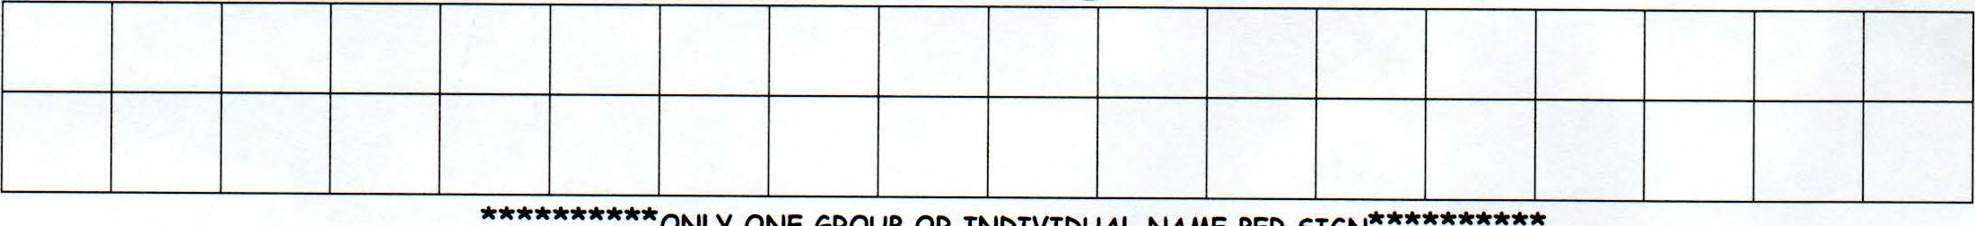
ONLY ONE GROUP OR INDIVIDUAL NAME PER SIGN
MAXIMUM LETTER PER LINE rs 18 INCLUDING SPACES BETWEEN WORDS. MAXIMUM LINES IS TWO. MESSAGES ARE NOT PERMITTED. ONLY STANDARD ABBREVIATIONS MAY BE USED. NAMES OF BUSINESSES, ORGANIZATIONS, FAMILIES OR INDIVIDUALS MAY BE USED.
DOT Approval County |  | DEP Approval
District | Date | Date

