The purpose of this activity is to use the chemical data on page two to evaluate the conditions of the Wolf Creek watershed. Attempt to answer the questions on the next page and discuss them as a group.
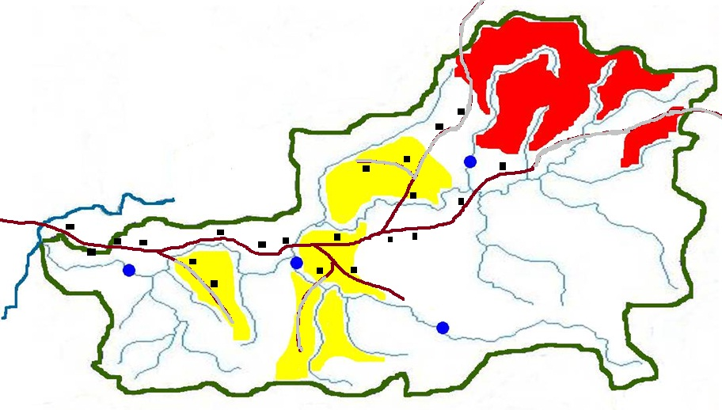
Wolfpen Run
Conner’s Run
Severna Run
UNT of Wolf Creek
Sandy Creek
Roaring Fork
Joe’s Run
Wolf Creek
Land use in the  Wolf Creek watershed |  | Assumptions: Agriculture consists of cropland and pasturelands; cropland is more prevalent; mining consists of active and abandoned mines; most of the mining in the watershed has been abandoned. You can assume that the areas of the map not having a land-use designation are mostly forested and un-disturbed except for some single-family homes (black) scattered throughout the watershed. There are also roads in the watershed indicated by either brown (paved) or gray (un-paved) lines.
 | Agriculture
 | Mining

Analysis Sample # 117 Result  pH 4.2  Nitrate ND  Alkalinity 0  Dissolved oxygen 5.2  Conductivity 800  Analysis Sample # 1423 Result  pH 7.6  Nitrate 2.0  Alkalinity 20  Dissolved oxygen 5.5  Conductivity 300 | Analysis Sample # 705 Result  pH 6.4  Nitrate 1.2  Alkalinity 20  Dissolved oxygen 6.0  Conductivity 450  Analysis Sample # 329 Result  pH 8.1  Nitrate ND  Alkalinity 40  Dissolved oxygen 8.6  Conductivity 200 | Sample stations: Below are the site numbers and descriptions for those shown on the map.
 |  | 1 | Wolf Creek mainstem downstream from Joe’s Run
 |  | 2 | Roaring Fork (station 1) just upstream of the confluence with Wolf Creek and below most of the agricultural practices
 |  | 3 | Roaring Fork (station 2) farther upstream on Roaring Fork above the agricultural practices
 |  | 4 | Severna Run downstream from mining activities

Based upon your analysis of the samples provided, match your sample # with its location. Enter the results in the table below. Note: The sample number refers to the entire suite of samples for a given location.

Sample # | Site # | Site description
 | 1 | Wolf Creek mainstem downstream from Joe’s Run
 | 2 | Roaring Fork (station 1) just upstream of the confluence with Wolf Creek and below most of the agricultural practices
 | 3 | Roaring Fork (station 2) farther upstream on Roaring Fork above the agricultural practices
 | 4 | Severna Run downstream from mining activities

Other questions to consider:

Would you choose different sites?
Would additional sites be necessary?
If you choose additional sites, explain your reasons why.
How many would you add and where would you place them?

Save this document, then email it to: timothy.d.craddock@wv.gov for an evaluation.

